# DATA ANALYTICS POWERED BY TABLEAU

PROJECT TITLE

*TEAM LEADER: SARANYA.S.K*

*TEAM MEMBERS: SELINA.S*

*SHENIJA SILVIO.S*

*SHERLIN.S*

# 

**PROJECT REPORT**

*1*. *INDRODUCTION*

*1.1 OVERVIEW*

*1.2 PURPOSE*

*2. PROBLEM DEFINITION & DESIGN THINKING*

*2.1 EMPATHY MAP*

*2.2 IDEATION & BRAIN STORMING MAP*

*3. RESULT*

*4. ADVANTAGES AND DISADVANTAGES*

*5. APPLICATIONS*

*6. CONCLUSION*

*7. FUTURE SCOPE*

The Tableau HR Scorecard:

Measuring Success in Talent Management

**1. INTRODUCTION**

**1.1 Overview**

**The Tableau HR Scorecard is a data-driven approach to measuring and evaluating the effectiveness of talent management within an organization. It leverages Tableau, a popular data visualization and business intelligence tool, to create visual representations of key HR metrics. These visualizations make it easier for HR professionals and organizational leaders to understand, analyze, and act on their talent management data. In summary, the Tableau HR Scorecard is a tool that leverages data visualization and analytics to measure, track, and improve talent management within an organization. It assists in making data-driven decisions to enhance HR practices and ultimately contribute to the achievement of an organization's strategic goals.**

**1.2 Purpose**

**The primary purpose of the Tableau HR Scorecard is to measure HR and talent management performance, identify strengths and weakness, data driven decision making, align HR with organizational goals, improve accountability and enhance communication within the HR department. In essence, the Tableau HR Scorecard serves as a valuable tool for HR professionals and organizations to gauge the effectiveness of their talent management efforts and make necessary adjustments to meet their business goals.**

**2. PROBLEM DEFINITION & DESIGN THINKING**

**2.1 Empathy Map**

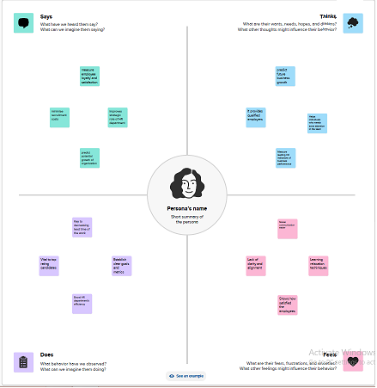

**2.2 Ideation & Brainstorming Map**

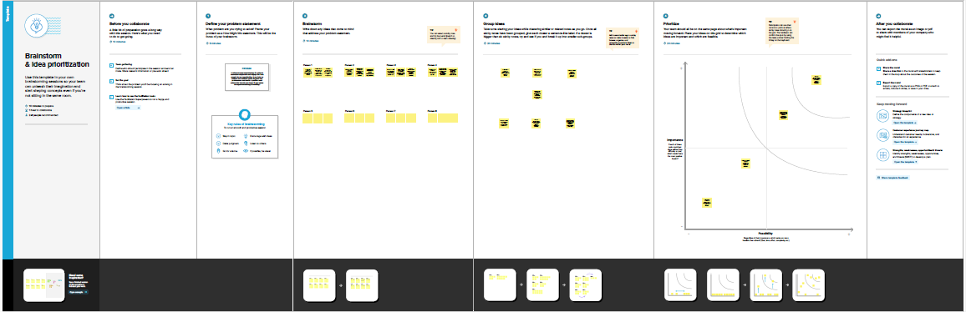

**3. RESULT**

**Dashboard**

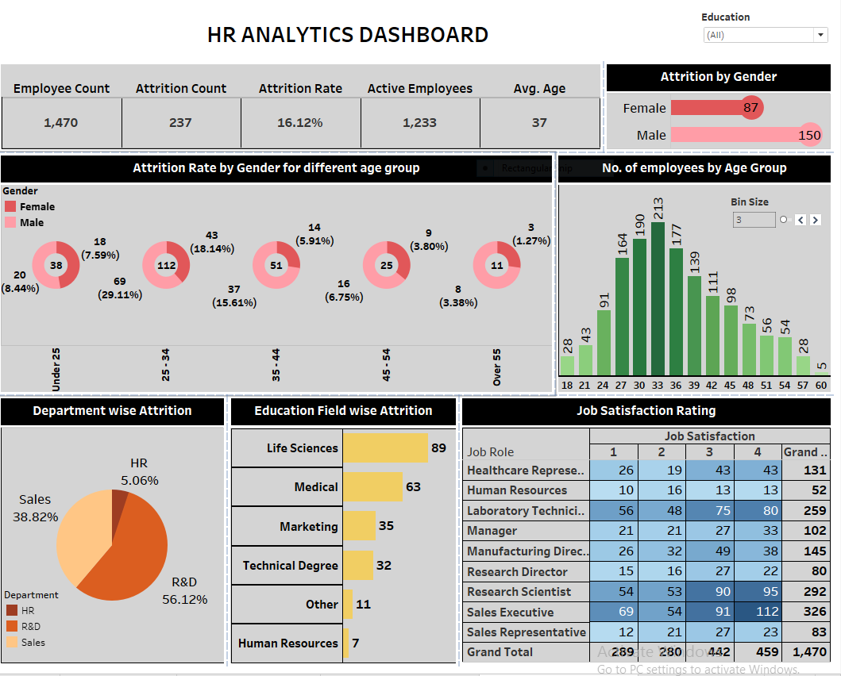

**Story**

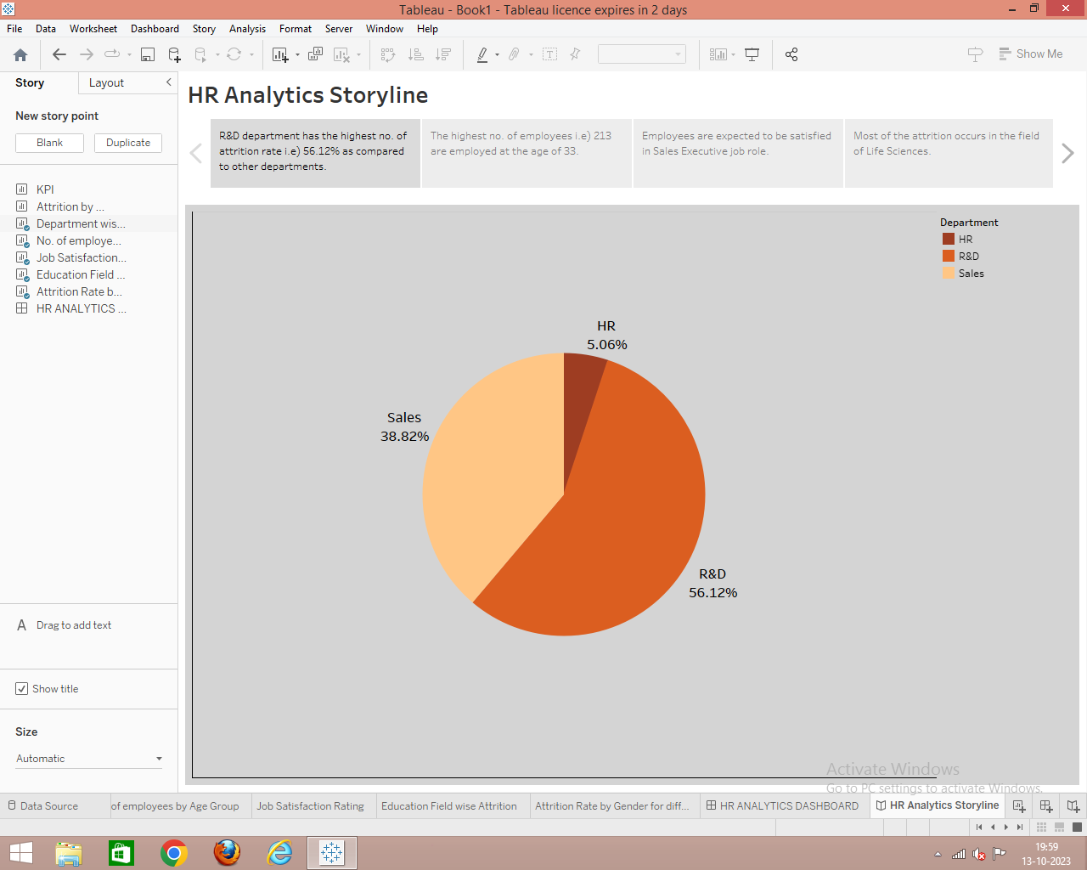

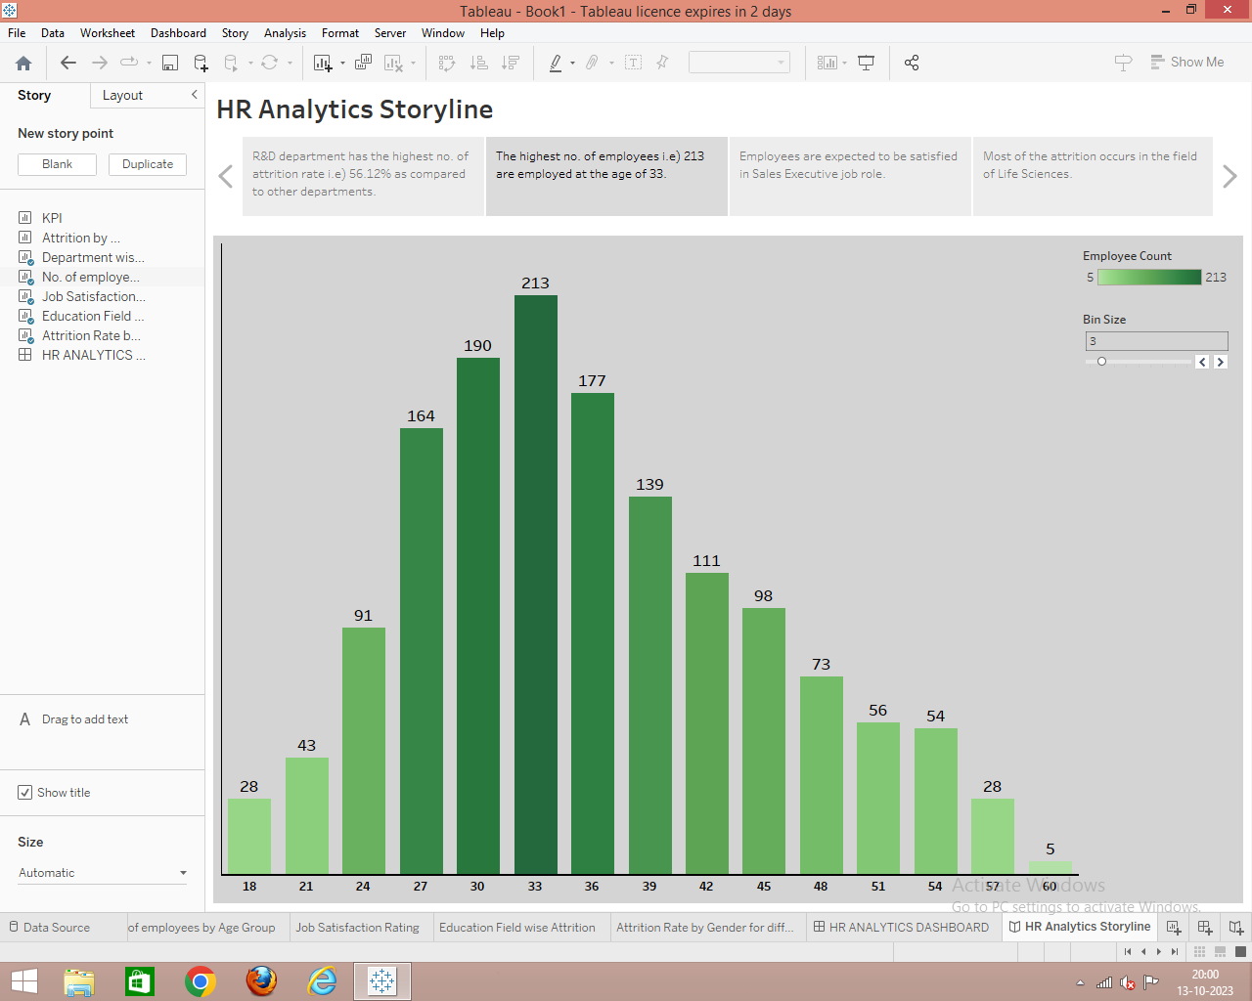

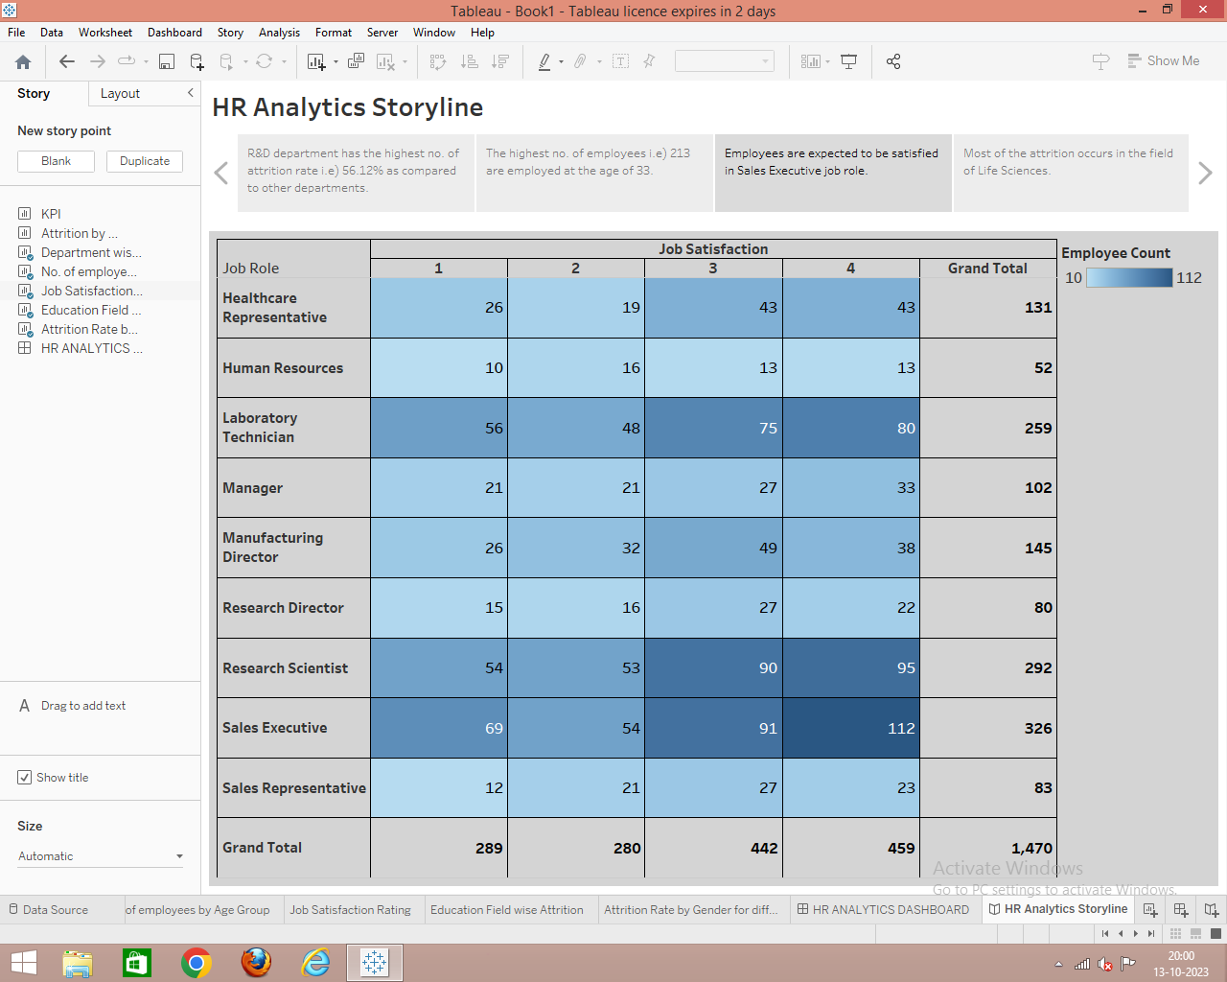

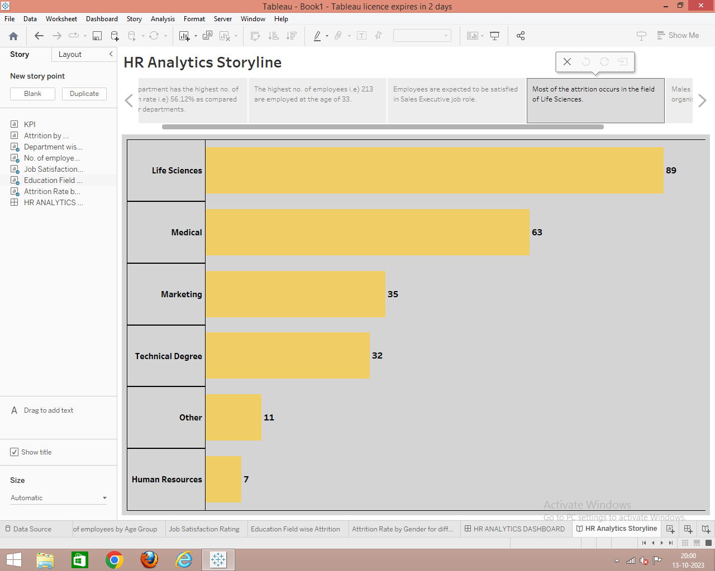

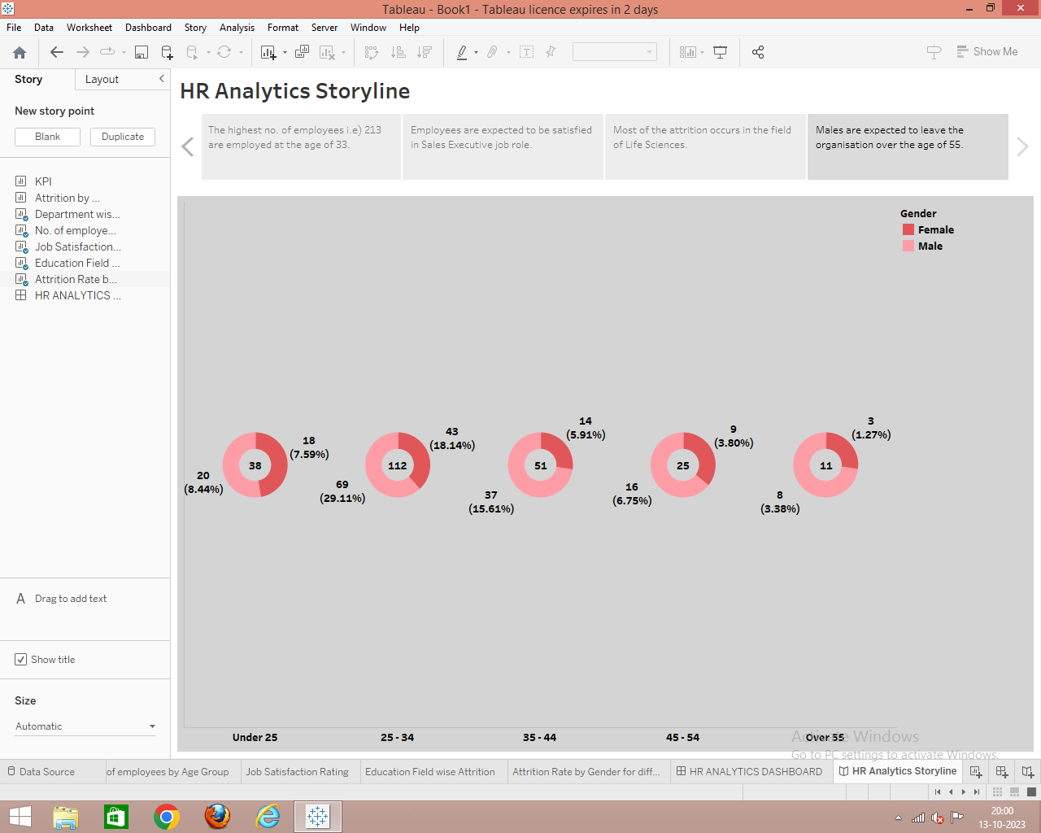

**4. ADVANTAGES**

● Improved Recruitment: Attracts top talent, ensuring a high-quality workforce.

● Employee Retention: Enhances job satisfaction and loyalty, reducing turnover.

● Skill Development: Nurtures employee skills and competencies, increasing productivity.

● Succession Planning: Ensures a pipeline of qualified individuals for key roles.

● Workforce Diversity: Promotes inclusivity and diverse perspectives.

● Cost Savings: Reduces recruitment and training costs associated with high turnover.

**DISADVANTAGES**

● Cost: Implementing and maintaining talent management programs can be expensive, especially for small businesses with limited resources.

● Time-Consuming: It often takes time to identify and develop talent, which can be a disadvantage in fast-paced industries.

● Complexity: Managing talent effectively requires a nuanced understanding of individual and organizational needs, which can be challenging.

● Resistance to Change: Employees may resist new talent management initiatives, leading to implementation difficulties.

● Inequity: If not implemented carefully, talent management strategies can lead to perceptions of favouritism and inequality.

**5. APPLICATIONS**

Talent Acquisition can be used to evaluate the effectiveness of recruitment processes, such as time-to-fill positions, quality of candidates, and cost per hire. The scorecard can measure employee performance using KPIs like productivity, goal attainment, and employee feedback. Training and Development It helps assess the impact of training programs by tracking skill development, knowledge retention, and training costs. By analyzing turnover rates and reasons for leaving, HR can identify areas for improvement in talent retention. The scorecard can track diversity metrics, helping organizations monitor progress toward diversity and inclusion goals.

**6. CONCLUSION**

In conclusion, the Tableau HR Scorecard is a valuable tool for organizations to measure and improve their talent management practices. By utilizing key performance indicators and metrics, it provides a data-driven approach to assess various aspects of HR, from recruitment and employee performance to retention and compliance. This helps organizations make informed decisions, enhance their talent management strategies, and align HR efforts with their overall business objectives. It's a comprehensive framework that empowers HR professionals to drive success in talent management by leveraging data and insights.

**7. FUTURE SCOPE**

The future scope of using a Tableau HR Scorecard in talent management is promising. As data analytics and visualization continue to play a crucial role in HR, Tableau's capabilities can help organizations make data-driven decisions in areas such as recruitment, employee performance, and workforce planning. It can provide insights into key HR metrics, enabling companies to optimize talent management strategies, reduce turnover, and improve employee engagement. Additionally, advancements in AI and machine learning can enhance predictive analytics in HR, making the Tableau HR Scorecard even more valuable in the future.